6 Editors introduction
Introduction 2
Header right click menu 2
Toggle Header 2
Flip to Bottom / Top 2
Collapse Menus 2
Hide Editortype Menu 2
Maximize Area 2
Editor Type menu 3
RMB menus at tools 3
Add Shortcut / Change Shortcut 4
Online Python Reference 4
Edit Source 4
Edit Translation 4
Reset to Default Value 4
Reset All to Default Value 4
Reset Single to Default Value 4
Unset 5
Add Driver 5
Add Drivers 5
Add Single Driver 5
Add to Keying Set 5
Add All to Keying Set 5
Add single to Keying Set 5
Remove from Keying Set 5
Copy Data Path 5
Copy to Selected 5
Resize Tool Shelf and Properties content 5
Hotkey recognition 6
The editor types 6
3D View 7
Image Editor 7
UV Editor 7
Shader Editor 8
Compositor 8
Texture Node editor 8
Video Sequence Editor 9
Movie Clip Editor 9
Dope Sheet Editor 9
Timeline Editor 10
Graph Editor 10
Drivers Editor 10
Nonlinear Animation Editor 11
Text Editor 11
Python Console 11
Info Editor 12
Toolbar Editor 12
Outliner Editor 12
Properties Editor 13
File Browser 13
Preferences 13

Introduction

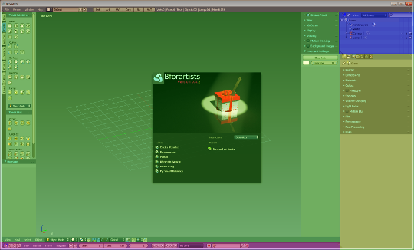
The Bforartists Interface is made of several workspaces. And every layout is made of several editors.

The editors brings the functionality to the layout. Every editor type has another purpose. The 3D View for example is made to modify 3D data such as meshes or curves.

In this chapter we will talk about the general aspects of the editors. And give an overview over the available editor types and their purpose.

The detailled description happens for every editor one by one then.

Header right click menu

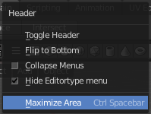
The header has a header menu that appears when you right click at it.

Toggle Header
Hides the header. To reveal it you have to click at the small triangle at the right side then.

Flip to Bottom / Top
Displays the header at the top or the bottom of the editor

Collapse Menus
Displays the text menus as one collapsed icon.

Hide Editortype Menu
Hides the editortype menu where you can switch to other editor types.

Maximize Area
Maximizes the editor. Ctrl + spacebar will return to normal mode.

Editor Type menu

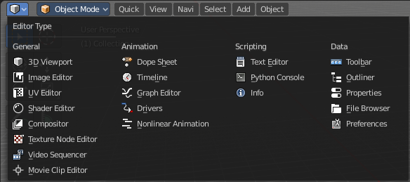
The Editor Type menu gives you an overview of all available editor types. And here you can switch to another editortype.

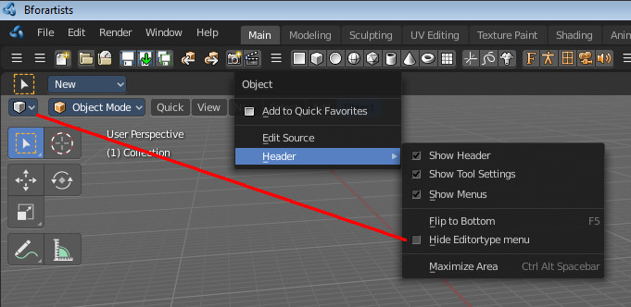
This menu is hidden in the standard workspaces. See Header Menu, Hide Editortype menu.

RMB menus at tools

Every tool or UI element has usually a RMB menu where you can find various things.
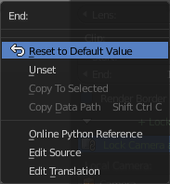
The content is varying, dependant of the tool where you right click at. Value edit boxes have for example a Reset to Default Value menu item. For other tools you might be able to add or change the shortcut here. They all have the last three menu items, Online Python Reference, Edit source and Edit translation.

A few examples:
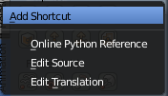 | 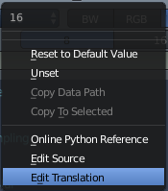 | 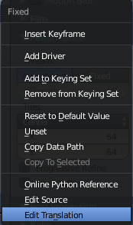 | 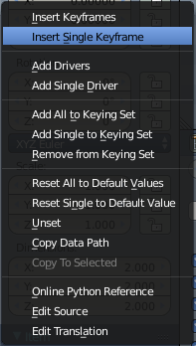

Add Shortcut / Change Shortcut
The Add Shortcut / Change Shortcut button allows you to assign a new shortcut to the tool or to change an existing shortcut for the tool. Note that this may or may not work proper. For some tools you might need to change the shortcut in the User preferences.

Online Python Reference
The Online Python Reference button opens the Bforartists Online Python reference page in your browser.

Edit Source
The Edit Source button opens the corresponding Python file for this element. Note that you need to be in the Scripting layout. The file loads in the Text editor there.

Edit Translation
This is a developer entry. It allows you to edit the *.mo translation files directly. But you need to have a special setup here. Which is currently not documented.

Reset to Default Value
Reset to Default Value is usually a RMB menu entry when you right click at a edit box. It resets the value to the default value.

Reset All to Default Value
Reset All to Default Value is usually a RMB menu entry when you right click at a edit box combo made of two, three or more edit boxes together. It resets the value for all the edit boxes in the combo to the default value.

Reset Single to Default Value
Reset Single to Default Value is usually a RMB menu entry when you right click at a edit box combo made of two, three or more edit boxes together. It resets the value for the single edit box under the mouse to the default value.

Unset
Unset is usually a RMB menu entry when you right click at a edit box. It is somehow similar to Reset to Default Value. But it clears the property instead of resetting it to the default value. Which can end in another value.

Add Driver
In Bforartists lots of things can be animated. Also buttons. Add Driver does exactly what it tells. It adds a driver for animation needs to the element.

Add Drivers
In Bforartists lots of things can be animated. Also buttons. Add Drivers does exactly what it tells. It adds a driver for animation needs to the elements.

Add Single Driver
In Bforartists lots of things can be animated. Also buttons. Add Driver does exactly what it tells. It adds a driver for animation needs to the single element under the mouse.

Add to Keying Set
Add to Keying Set adds the information of the element to the current keyframe.

Add All to Keying Set
Add All to Keying Set adds the information of the element to the current keyframe.

Add single to Keying Set
Add to Keying Set adds the information of the element to the current keyframe.

Remove from Keying Set
Remove from Keying Set removes the information of the element from the current keyframe.

Copy Data Path
Copy Data Path copies the RNA data path for this property

Copy to Selected
Copy to Selected copies the property of this element to selected objects or bones

Resize Tool Shelf and Properties content

You can resize the Tool Shelf content and the Properties Sidebar content. This means that you can zoom in or out. This trick also works in the Properties Editor.
Move the mouse over the upper region of the Tool Shelf.
Hold down Ctrl key
Click with Middle Mouse button. The mouse pointer will turn into two white triangles.
Now drag up or down to resize the area content

OR

Move the mouse over the upper region of the Tool Shelf.
Simply press Numpad + or Numpad -
To reset the area content to default scale move the mouse over the area and press Home key ( german keyboard layout Pos 1)

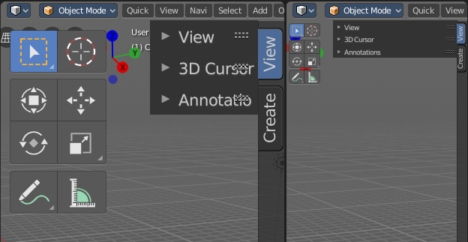

Hotkey recognition

What hotkeyset works is dependant of the mouse position, over which editor the mouse is. Means when your mouse is over the 3d View, then the hotkeys from the 3D View gets recognized. This means when your mouse is not over the 3D View but the Outliner, and you press the hotkey for let's say move, then this hotkey will not be recognized.

A special behaviour shows the sidebars here. They are part of the editors. But to have the mouse over the toolbars at the side can already prevent a hotkey from being triggered. Your mouse needs to stay in the active part of the editor.

The editor types
Bforartists provides a number of different Editor types for different purposes. For example, the 3D view is made to modify the 3D data, such as meshes or curves. You can have more than one editor window open at the same time.

3D View  The 3D View is the editor where you do your 3D work. Here you can model meshes, etc. . It's the core editor for everything where you work at your 3D data.  You will find it in every layout where you need to display your 3d data. | 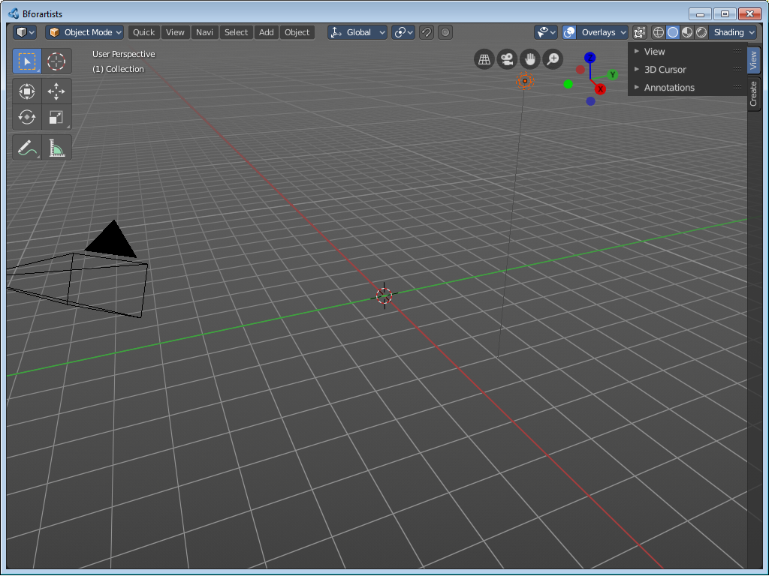

Image Editor  The Image Editor is the place where you work with textures. | 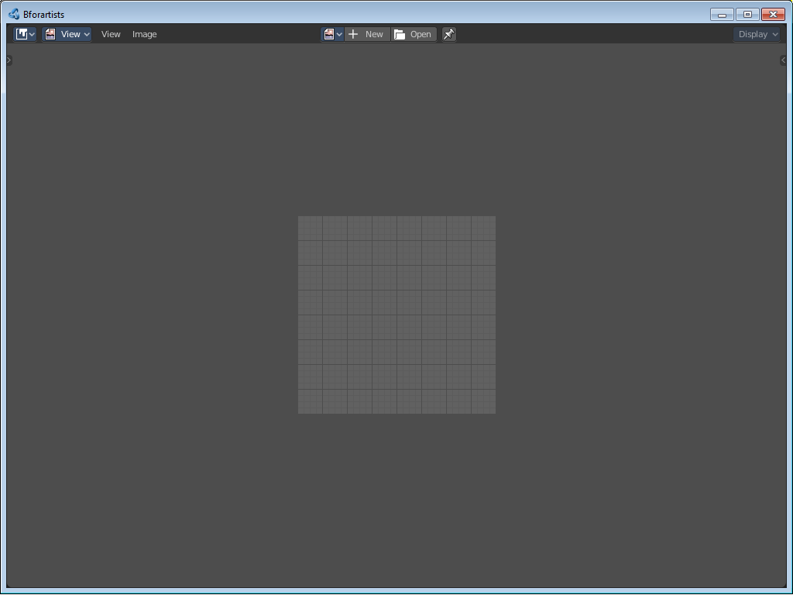

UV Editor  The UV Editor is the place where you work with UV mapping. It starts pretty similar to the Image editor. But contains the UV tools. | 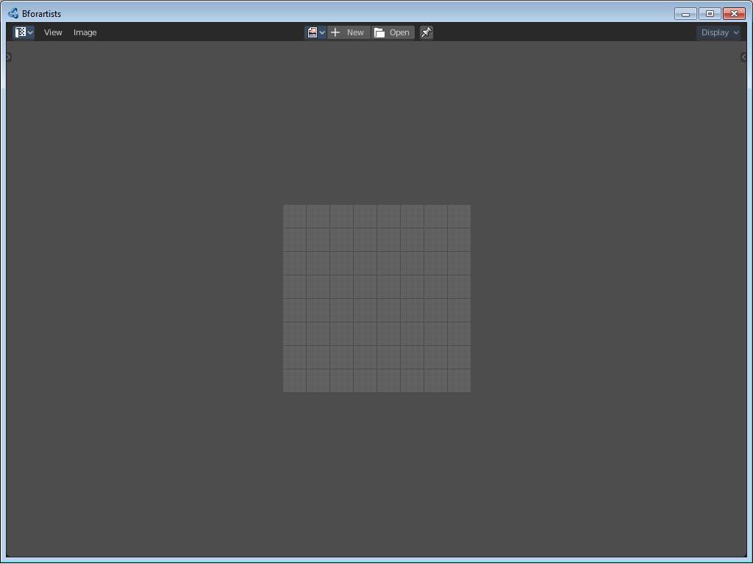

Shader Editor

The Shader Editor allows you to create and edit your shaders for your 3d meshes. It is node based.

Compositor  Here you can do post processing. It is node based. | 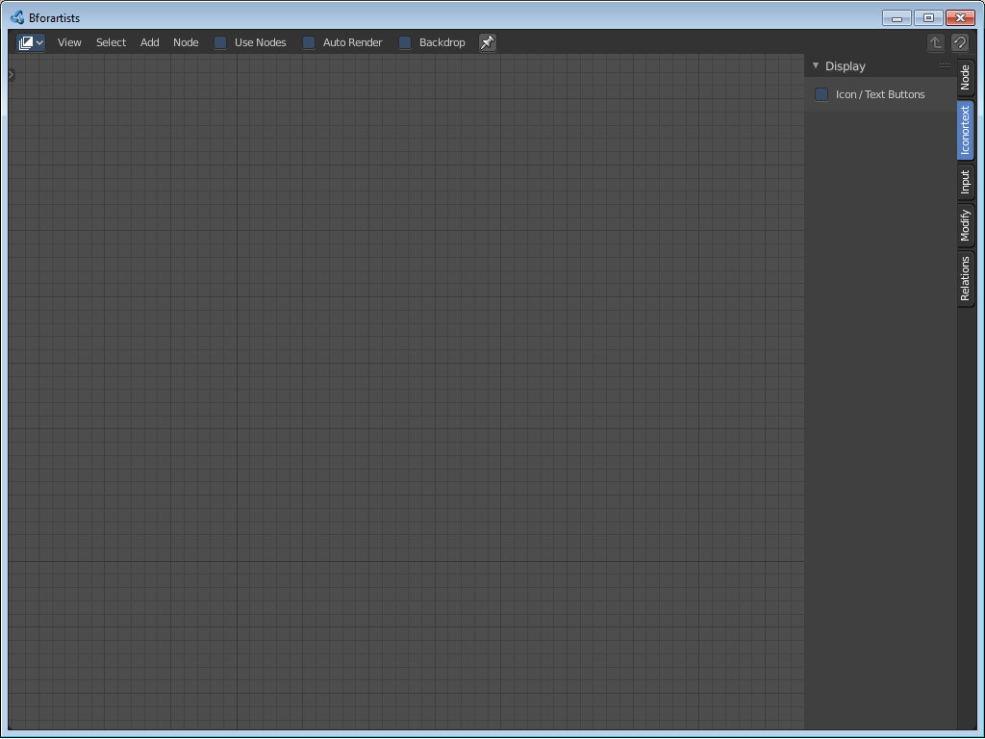

Texture Node editor

Here you can do texture work. It is node based.

Video Sequence Editor  The video sequence editor allows you to work with video and audio clips. Here you can cut videos.  This editor can be found in the video editing layout. | 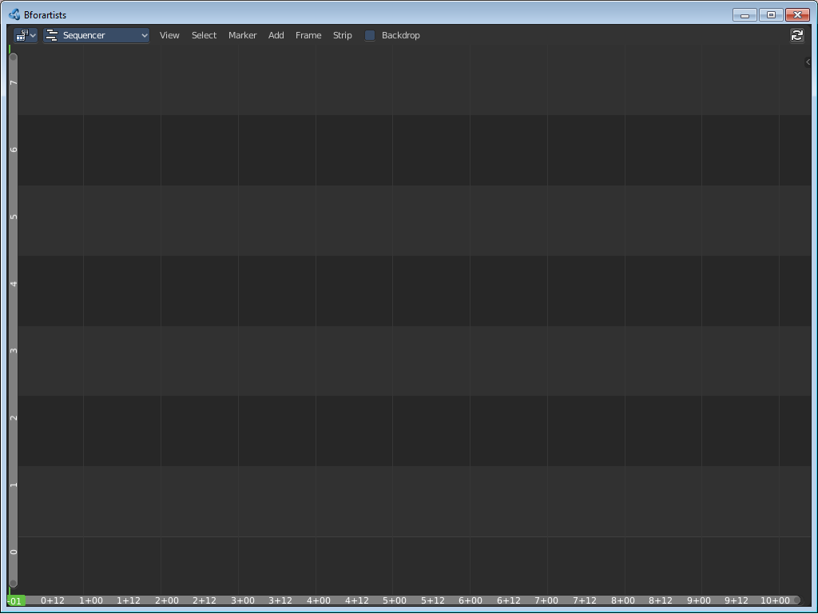

Movie Clip Editor  The movie clip editor is for tracking purposes.  You will find it in the Motion Tracking layout. | 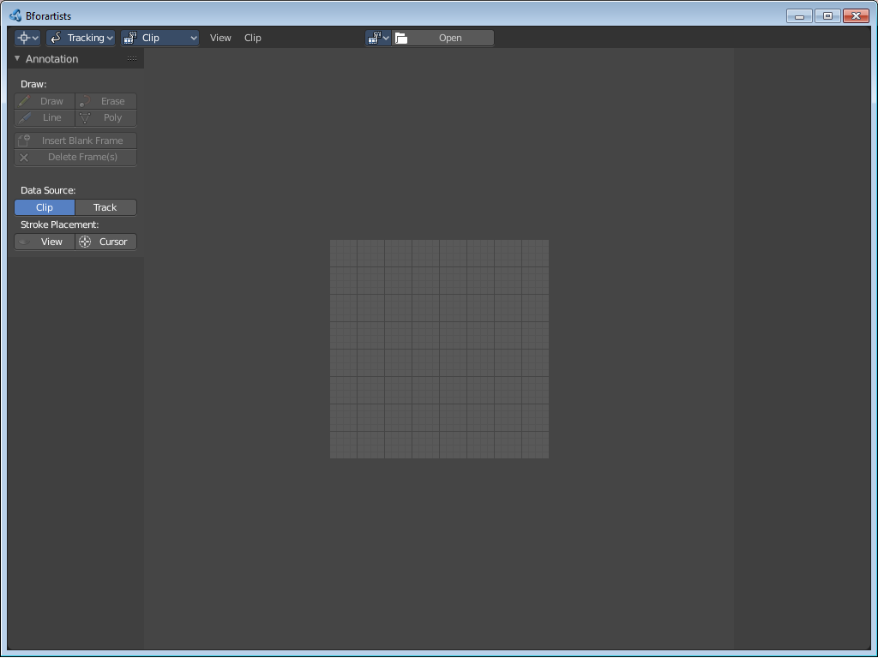

Dope Sheet Editor

The Dope Sheet Editor is the place where you deal with keyframes.

The Dope Sheet Editor is one of five special editors for animation needs. You will find it in the animation layout.

Timeline Editor  The timeline editor provides you with a toolbar for all animation needs. Start, stop, record, set keying set, etc.  The Timeline Editor is one of five special editors for animation needs. You will find it in the animation layout. | 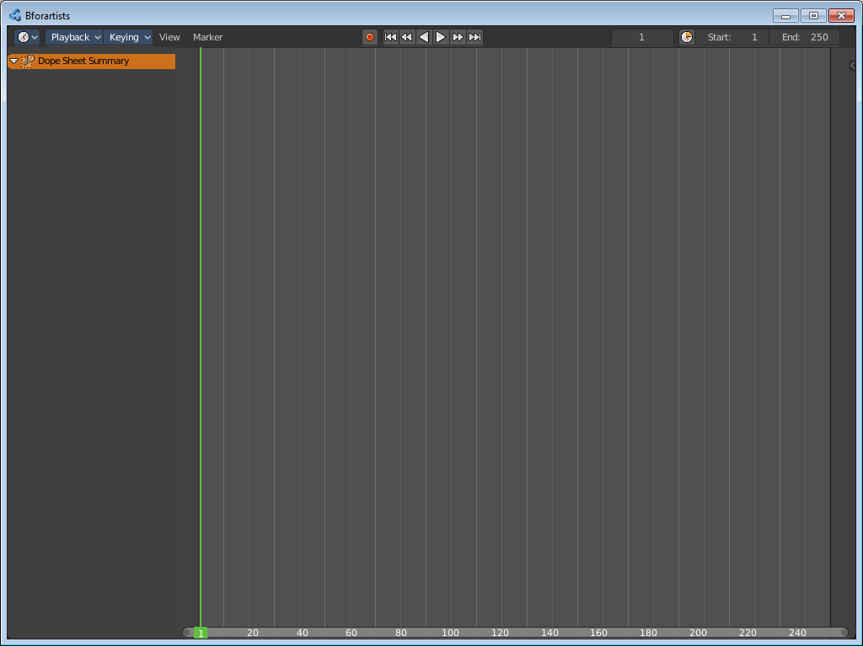

Graph Editor  The Graph Editor is the place where you work with function curves.  The Graph Editor is one of five special editors for animation needs. | 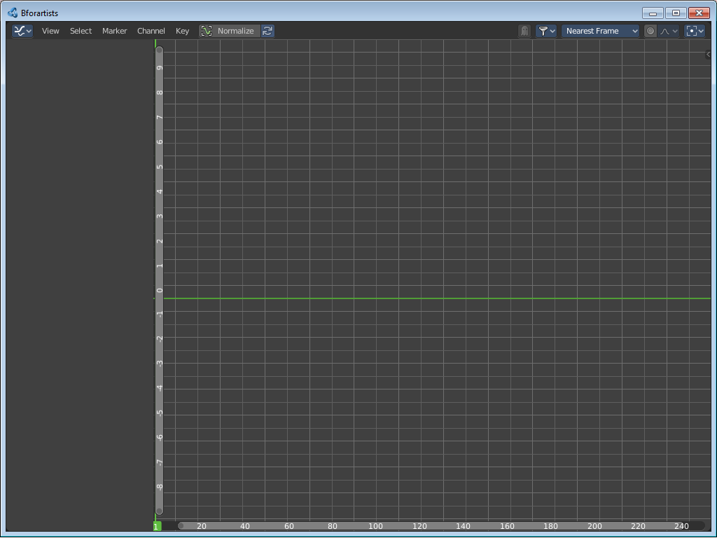

Drivers Editor  Here you can see and edit drivers.  The Drivers Editor is one of five special editors for animation needs. | 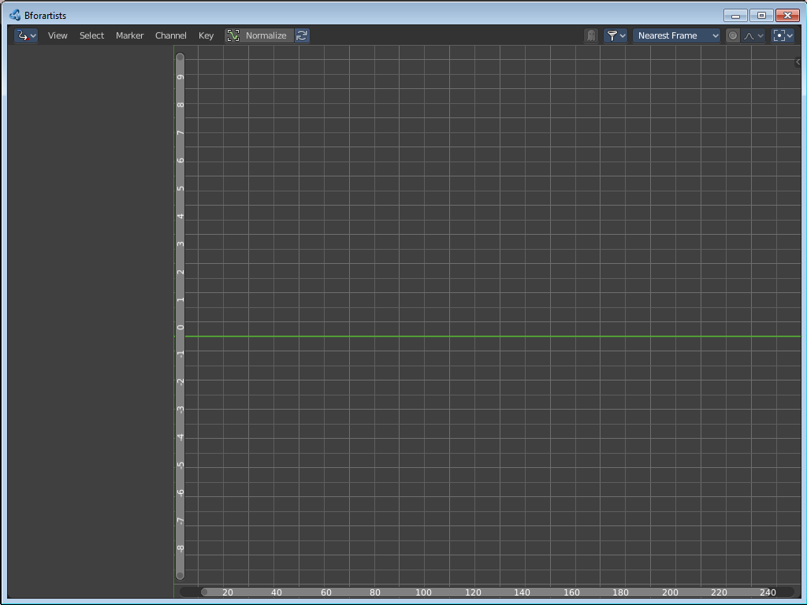

Nonlinear Animation Editor

The Nonlinear Animation Editor, in short NLA Editor, is the place where you work with Clips and Actions.

The Nonlinear Animation Editor is one of five special editors for animation needs.

Text Editor

The Text Editor is the place where you write code. The scripts for addons for example.

You will find it in the Scripting layout.

Python Console  The Python console gives you access to the Python API.  You will find it in the Scripting layout. | 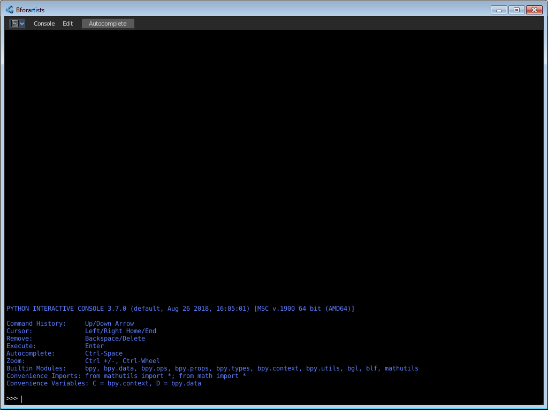

Info Editor

The Info Editor provides you with a list of the last performed operations. Including error messages.
You will find it in the Scripting layout.

Toolbar Editor  It is as the name says a toolbar. Usually just the header area is visible. The rest of the editor has no purpose. | 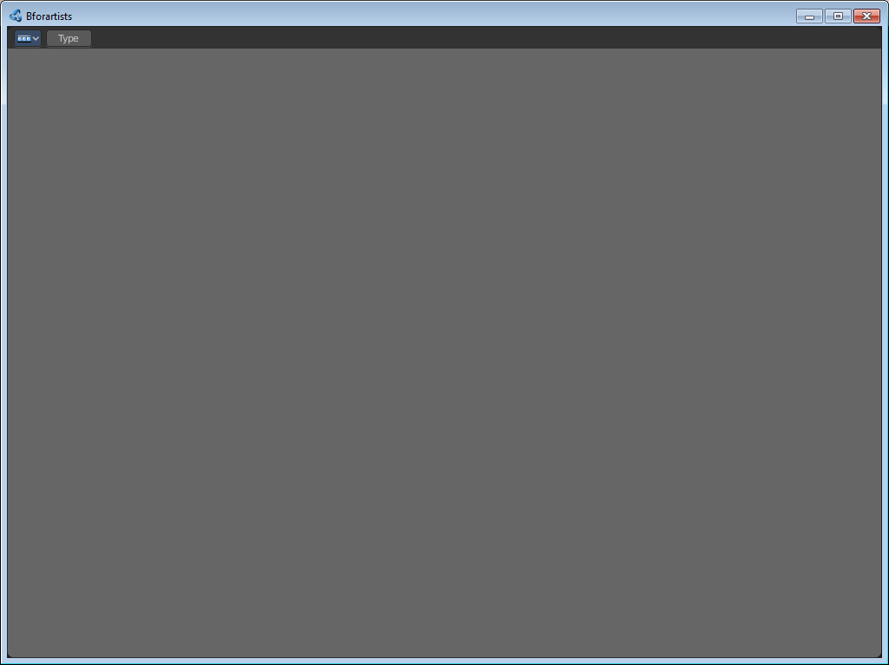

Outliner Editor  The Outliner is the place that gives you an overview of what is in the scene and in the file. | 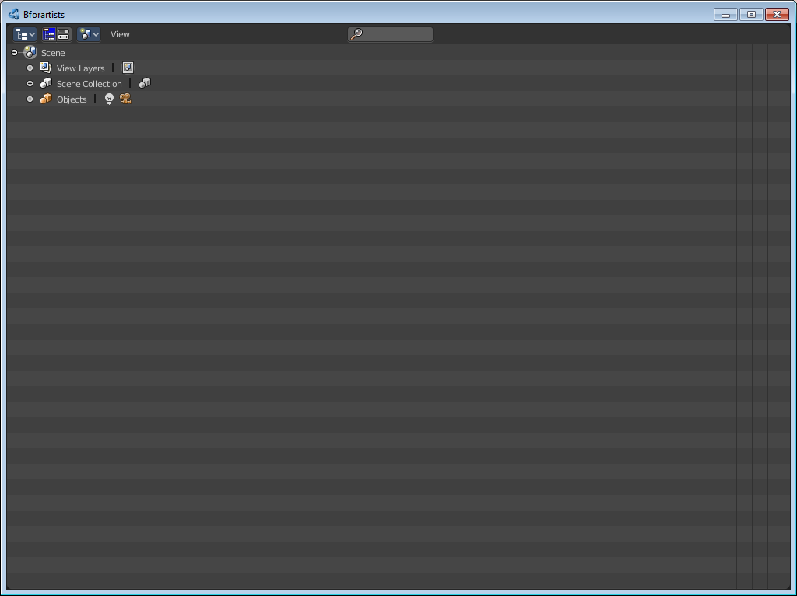

Properties Editor  The Properties editor is the place where you can see and tweak all properties for the 3D scene. The range goes from render settings across object settings up to particle settings. It is the data heart. | 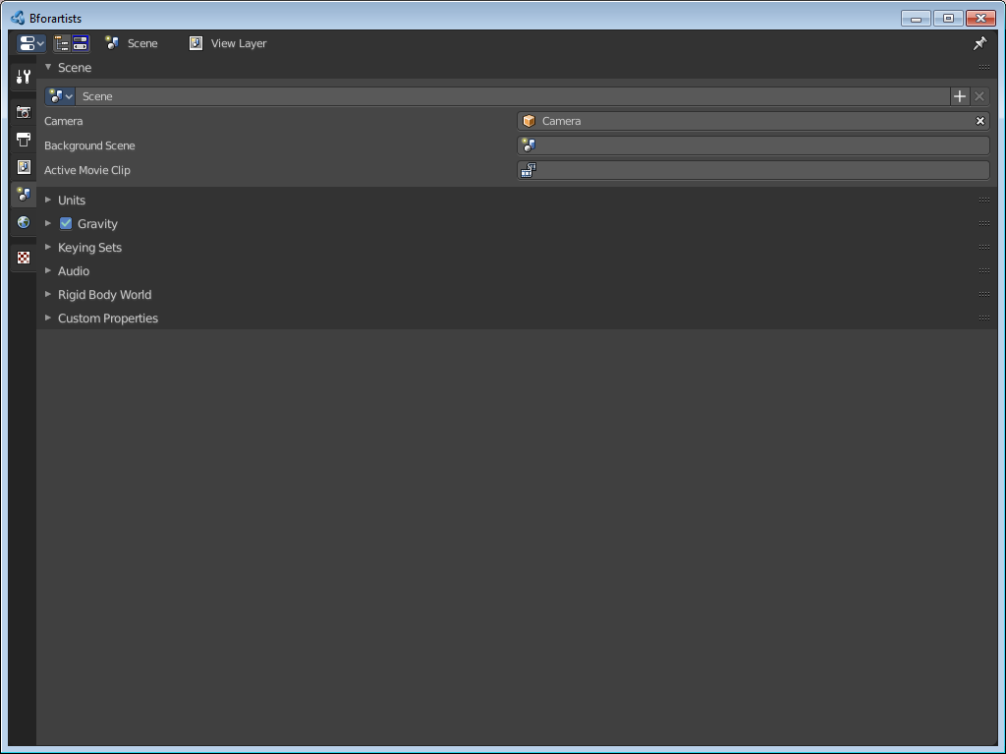

File Browser  The File Browser is the editor in which you can load and save data. Your last blend file for example.  This editor is not part of the standard workspaces. It usually gets called when you load or save a data. | 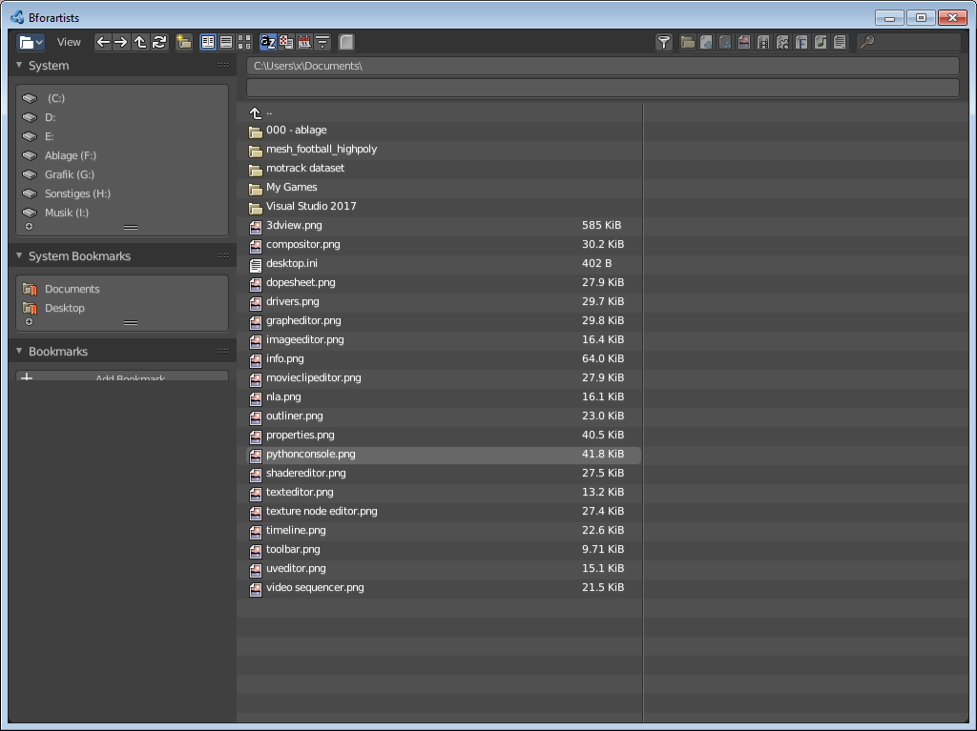

Preferences  The Preferences is the place where you manage all the settings of the software. Theme, Keymap, etc.  This editor is not present in the standard workspaces. This editor can be called from the edit menu in the topbar. | 